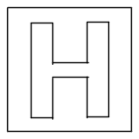

RAFFLES INSTITUTION (JUNIOR COLLEGE)
PRELIMINARY EXAMINATION 2009

HIGHER 2

CHEMISTRY 9746/01

Paper 1 Multiple Choice 24 September 2009
1 hour

Additional Materials: Multiple Choice Answer Sheet
Data Booklet

READ THESE INSTRUCTIONS FIRST

Do not open this question booklet until you are told to do so.

Write in soft pencil.
Do not use staples, paper clips, highlighters, glue or correction fluid.
Write your name, class and index number in the spaces provided on the Answer
Sheet.

There are forty questions on this paper. Answer all questions.

For each question there are four possible answers A, B, C and D.
Choose the one you consider to be correct and record your choice with a soft
pencil on the separate Answer Sheet.

Read the instructions on the Answer Sheet very carefully.

Each correct answer will score one mark. A mark will not be deducted for a wrong
answer.

Any rough working should be done in this booklet.

This document consists of 16 printed pages.

Section A

For each question there are four possible answers, A, B, C, and D. Choose the one you consider to be correct.

1 The following reaction is used in the titration of iron(II) solution with acidified potassium dichromate(VI).

6Fe²⁺ + Cr₂O₇^{2–} + 14H⁺ ⎯→ 6Fe³⁺ + 2Cr³⁺ + 7H₂O

If 50.0 cm³ of an iron(II) solution require 45.20 cm³ of 0.100 mol dm^{–3} potassium dichromate(VI) for reaction, what is the mass of Fe²⁺ ions in 1 dm³ of the iron(II) solution?

A 12.6 g | B 25.2 g
C 30.3 g | D 60.5 g

2 Of the following, which is the strongest oxidising agent?

A O₂⁺
B O₂
C O₂–
D O₂^{2–}

3 Which of the following equations represents the third ionisation energy of titanium?

A Ti(s) ⎯→ Ti³⁺(g) + 3e–

B 3Ti(g) ⎯→ 3Ti⁺(g) + 3e–

C Ti²⁺(g) ⎯→ Ti³⁺(g) + e–

D 3Ti²⁺(g) ⎯→ 3Ti³⁺(g) + 3e–

4 Which form of orbital hybridisation can form molecules or ions that are square pyramidal in shape?

A sp²
B sp³
C sp³d
D sp³d²

[Turn over
5 Which one of the following pairs does not contain two species with the same molecular shape?

A SCl₂ and SO₂

B BCl₃ and BrCl₃

C BeF₂ and BrF₂–

D ClF₄⁺ and PF₄–

6 The standard enthalpy changes for three reactions are given below.

C(s) + 2H₂(g) ⎯→ CH₄(g) ΔH○ = x

C(s) + O₂(g) ⎯→ CO₂(g) ΔH○ = y

H₂(g) + ½O₂(g) ⎯→ H₂O(l) ΔH○ = z

What is the standard enthalpy change for the reaction

CH₄(g) + 2O₂(g) ⎯→ CO₂(g) + 2H₂O(l)?

A x + y – z

B z + y – 2x

C 2z + y – x

D 2z + y – 2x

7 Graphite and diamond are two allotropes of carbon. Although graphite is thermodynamically more stable than diamond at 25 °C and 1 atm, a piece of diamond will not transform into graphite, even over a period of one million years.

Which of the following correctly explains this observation?

A ΔG for the reaction diamond ⎯→ graphite is greater than zero.

B ΔH for the reaction diamond ⎯→ graphite is greater than zero.

C The reverse reaction graphite ⎯→ diamond proceeds quickly.

D The reaction diamond ⎯→ graphite has a large activation energy.

[Turn over
8 The rate of the reaction between substances A and B is found to follow the rate law
rate = k [A]^{m} [B]

where k is the rate constant and has units of mol^{–2} dm⁶ s^{–1}.

Two experiments to study the kinetics of this reaction were carried out and the data obtained are tabulated below.

Experiment | Initial [A]  / mol dm^{–3} | Initial [B]  / mol dm^{–3} | Initial rate  / mol dm^{–3} s^{–1}
1 | 0.040 | 0.080 | R
2 | 0.020 | y | ½ R

What is the value of y in Experiment 2?

A 0.020

B 0.040

C 0.160

D 0.320

9 The dissociation of dinitrogen tetroxide into nitrogen dioxide is represented by the equation below.
N₂O₄(g) ⇌ 2NO₂(g); ΔH = +52.7 kJ mol^{–1}

If the temperature of an equilibrium mixture of these gases is increased at constant pressure, the volume of the mixture will

A decrease, because a shift in position of equilibrium towards the left would more than counteract any thermal expansion.

B decrease, because a shift in position of equilibrium towards the left would also produce cooling and hence thermal contraction.

C increase, but only because of a shift in position of equilibrium towards the right.

D increase, both because of a shift in position of equilibrium towards the right and because of thermal expansion.

[Turn over
10 Two gases, X₂ and Y, react as follows:

X₂(g) + 3Y(g) ⇌ X₂Y₃(g)

A mixture containing 0.50 mol of X₂ and 0.50 mol of Y was heated in a 0.50 dm³ closed container. When the reaction reached equilibrium, 0.10 mol of X₂Y₃ was produced.

What is the value of the equilibrium constant, K_{c}, for this reaction?

A 0.98 | B 1.25
C 3.91 | D 31.2

11 The numerical values of the solubility products at 25 °C for AgCl and AgI are 1.6 × 10^{–10} and 8.0 × 10^{–17} respectively.

What is the equilibrium constant for the reaction below?
AgCl(s) + I–(aq) ⇌ AgI(s) + Cl–(aq)

A 1.3 × 10^{–26} | B 5.0 × 10^{–7}
C 2.0 × 10⁶ | D 1.3 × 10¹⁶

12 The graph shows the change in pH when 0.10 mol dm^{–3} acid is gradually added to V cm³ of 0.10 mol dm^{–3} alkali.

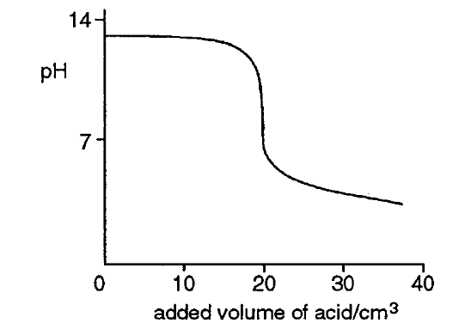

Which one of the following combinations could have given these results?

V Alkali Acid

A 10 Ba(OH)₂ CH₃CO₂H

B 20 Sr(OH)₂ HCl

C 10 Ca(OH)₂ H₂SO₄

D 20 NaOH HO₂C−CO₂H

[Turn over

13 Use of the Data Booklet is relevant to this question.

A student connects a Cu²⁺/Cu half-cell to a Ag⁺/Ag half-cell. The salt bridge contains aqueous Na₂SO₄. The voltage measured across the electrodes is found to be +0.42 V.

Which of the following could be a reason for the discrepancy between the calculated Eº_{cell} and the observed value of +0.42 V?

A The piece of copper in the Cu²⁺/Cu half-cell was too small.

B The piece of silver in the Ag⁺/Ag half-cell was too large.

C The concentration of Cu²⁺ was larger than 1 mol dm^{–3}.

D The concentration of Ag⁺ was larger than 1 mol dm^{–3}.

14 Consecutive elements A, B and C are in Period 3 of the Periodic Table. B has the highest first ionisation energy and the lowest melting point among the three elements.

What could be the identities of A, B and C?

A sodium, magnesium, aluminium

B magnesium, aluminium, silicon

C aluminium, silicon, phosphorus

D silicon, phosphorus, sulfur

15 Two solutions were prepared by dissolving a chloride and an oxide of the elements in the third period of the Periodic Table in separate portions of water.

Both solutions prepared can be used to dissolve Al₂O₃ but only one can be used to dissolve SiO₂.

Which of the following could be the chloride and the oxide used?

A NaCl and SO₃
B PCl₅ and Na₂O
C MgCl₂ and MgO
D SiCl₄ and P₄O₁₀

[Turn over
16 P, Q and R are Group II elements. They form compounds with the following properties:

- P(NO₃)₂ has a higher thermal decomposition temperature than R(NO₃)₂.

- RCO₃ has a more endothermic enthalpy change of decomposition than QCO₃.

Which of the following statements is correct?

A PO has a more exothermic lattice energy than RO.

B QCl₂ has more covalent character than PCl₂.

C R is more reducing than P.

D Q is Mg and R is Ba.

17 Aqueous silver nitrate is treated with successive additions of:

(i) an excess of aqueous potassium chloride

(ii) an excess of aqueous ammonia

(iii) an excess of aqueous potassium bromide

Which one of the following diagrams represents the mass of precipitate (ppt) present after each addition?

A

B

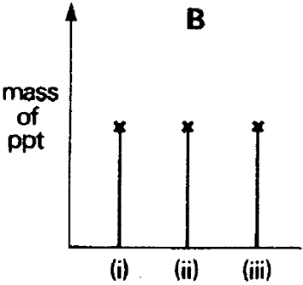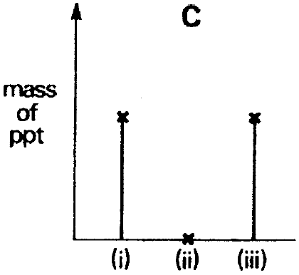

D

C

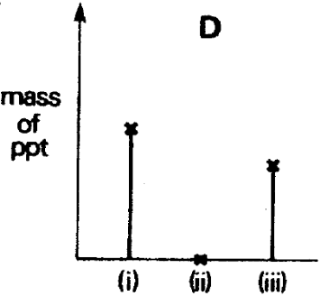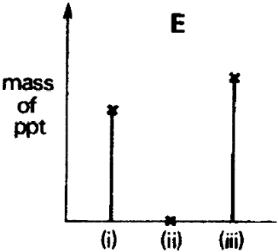

[Turn over
18 Nickel(II) ion forms a red complex with ligand L (shown below) at room temperature.

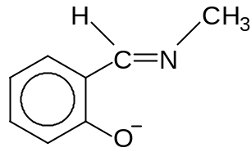
L

The graph below was obtained when the colour intensities of mixtures of a 4 x 10^{–3} mol dm^{–3} solution of L and a 3 x 10^{–3} mol dm^{–3} solution of nickel(II) chloride were measured using a colorimeter at room temperature.

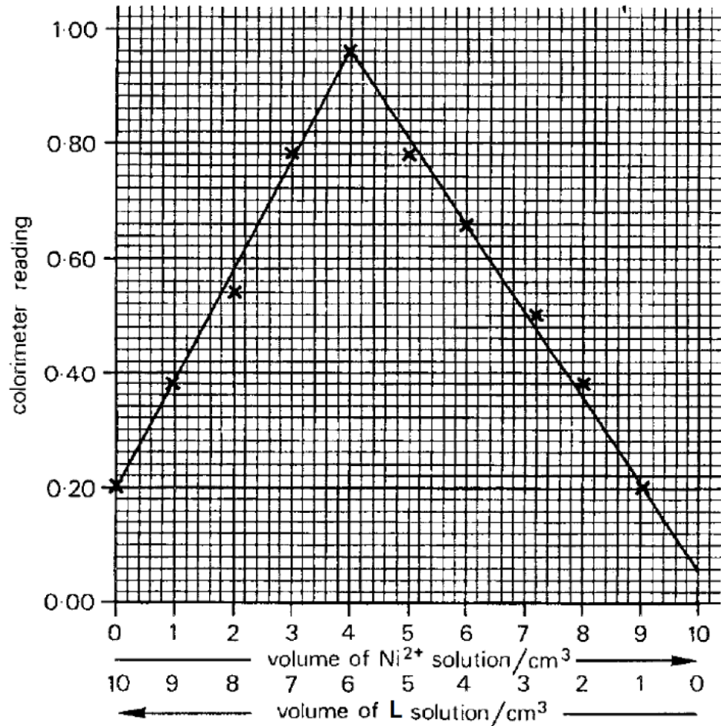

Which one of the following statements regarding the ligand L or the nickel(II) complex is correct?

A L is a monodentate ligand.

B The nickel(II) complex is negatively charged.

C The nickel(II) complex absorbs red light strongly.

D The co-ordination number of nickel in the complex is 4.

[Turn over
19 Vitamin D is a group of fat-soluble prohormones. It plays an important role in regulating calcium level in blood and is needed for bone growth. The structure of one major form of vitamin D, vitamin D2 (or calciferol), is shown below.

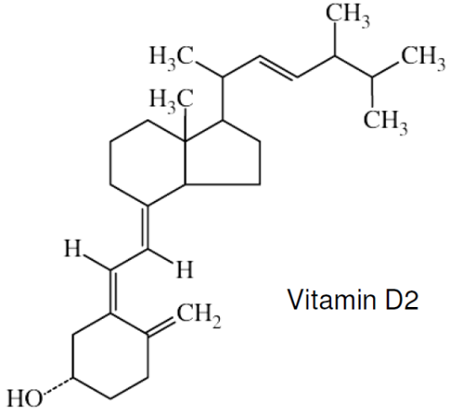

How many chiral carbons are there in a molecule of vitamin D2?

A 5 | B 6
C 7 | D 8

20 Deuterium (D or ²H) is a heavy isotope of hydrogen. A deutero-hydrocarbon has the part-structural formula shown below.

CDH=CH−CH=C(C₃H₇)₂

What is the total number of isomers with the above part-structural formula?

A 4 | B 8
C 10 | D 12

21 Compound M (C₆H₈) gives compound N (C₄H₆O₄) on oxidation. One mole of M reacts with two moles of hydrogen gas in the presence of platinum catalyst.

Which of the following shows the structure of M?

A | 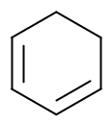 | B | CH₂=CH–CH=CH–CH=CH₂
C | CH₂=CH–CH₂CH₂–CH=CH₂ | D | 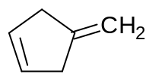

[Turn over
22 A reaction scheme showing the formation of a dicarboxylic acid from a compound X is given below.

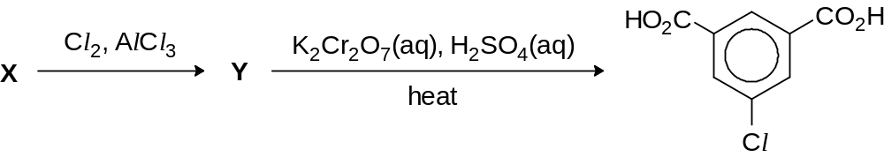

Which of the following could be compounds X and Y?

compound X compound Y

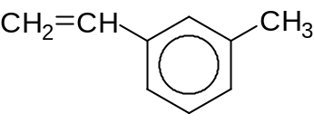
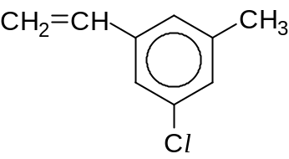

A

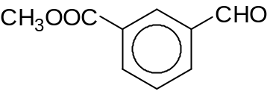
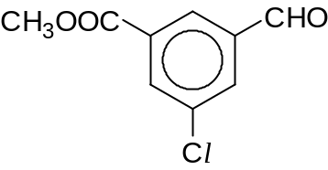

B

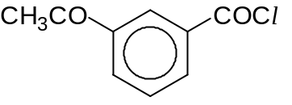
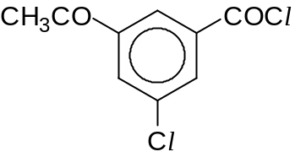

C

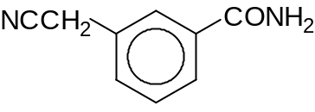
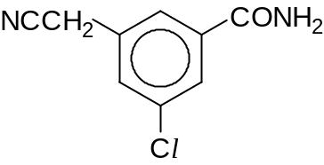

D

23 In which of the following reactions would the reactive intermediate be the same?

Reaction 1: (CH₃)₃CCl ⎯→ intermediate ⎯→ (CH₃)₃CCN

Reaction 2: CH₃COCH₃ ⎯→ intermediate ⎯→ (CH₃)₂C(OH)CN

Reaction 3: (CH₃)₂C=CH₂ ⎯→ intermediate ⎯→ (CH₃)₃CBr

A Reactions 1 and 2.

B Reactions 2 and 3.

C Reactions 1 and 3.

D Reactions 1, 2 and 3.
[Turn over

24 Compound P

- reacts with alkaline aqueous iodine when warmed

- reacts with hot acidified potassium dichromate(VI)

- reacts with 2,4-dinitrophenylhydrazine

- does not react with Fehling’s solution

What can P be?

A CH₃COCH₂CH₂COCH₃

B CH₃CH₂COCH₂CH₂OH

C CH₃CH(OH)CH₂CH₂CHO

D CH₃COCH₂CH₂CH(OH)CH₃

25 A student tested the compound below with Br₂(aq) and Tollens’ reagent.

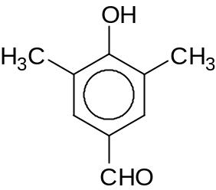

What are the expected observations?

with Br₂(aq) warm with Tollens’ reagent

A decolourisation of brown Br₂(aq) silver mirror

B no decolourisation of Br₂(aq) silver mirror

C decolourisation of brown Br₂(aq) no silver mirror

D no decolourisation of Br₂(aq) no silver mirror

26 Which of the following statements best explains why the boiling point of butanal (76 ºC) is higher than that of pentane (36 ºC)?

A There are permanent dipole–permanent dipole interactions between butanal molecules, but not between pentane molecules.

B There are hydrogen bonds between butanal molecules, but not between pentane molecules.

C The butanal molecule has a larger surface area than the pentane molecule.

D The covalent bonds in the butanal molecule are stronger than those in the pentane molecule.

[Turn over
27 One industrial preparation of ethanoic acid is the direct carbonylation of methanol, using a rhodium catalyst.

rhodium catalyst
CH₃OH + CO ⎯⎯⎯⎯⎯⎯⎯⎯⎯⎯→ CH₃CO₂H

Which compound could be expected to produce HO₂CCH(CH₂CO₂H)₂ by this method?

A HOCH₂CH(OH)CO₂H | B HOCH₂CH(CH₂CO₂H)₂
C HO₂CCH(OH)CH₂CO₂H | D HOCH₂CH(OH)CH₂CO₂H

28 Which of the following shows the given ions arranged in the order of increasing pK_{b} values?

A ethanoate ion, phenoxide ion, 4-nitrophenoxide ion, ethoxide ion

B ethanoate ion, 4-nitrophenoxide ion, phenoxide ion, ethoxide ion

C ethoxide ion, 4-nitrophenoxide ion, phenoxide ion, ethanoate ion

D ethoxide ion, phenoxide ion, 4-nitrophenoxide ion, ethanoate ion

29 Aspartame is an artificial sweetener marketed under a number of trademark names, including Equal and NutraSweet. It has the following structure:

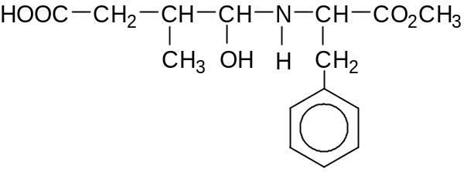

Which reagent does not react with aspartame at room temperature?

A Br₂ | B CH₃COCl
C Na₂CO₃ | D PCl₅

30 An organic compound Q was refluxed with aqueous sodium hydroxide. When the resulting mixture was distilled, an organic distillate was obtained.

Which one of the following is Q?
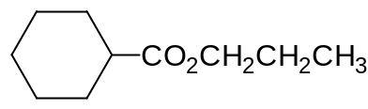
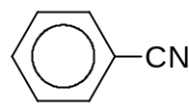  A | B
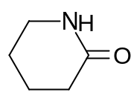  C | 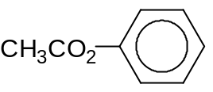  D
[Turn over

Section B

For each of the following questions, one or more of the three numbered statements 1 to 3 may be correct.

Decide whether each of the statements is or is not correct (you may find it helpful to put a tick against the statements that you consider to be correct).

The responses A to D should be selected on the basis of

A | B | C | D
1, 2 and 3  are  correct | 1 and 2  only are  correct | 2 and 3  only are  correct | 1 only  is  correct

No other combination of statements is used as a correct response.

31 When two liquids are mixed, heat may be evolved if intermolecular bonds formed are stronger than those broken, even if there is no chemical reaction.

Which pairs of liquids, when mixed, will give out heat?

1 CHCl₃ and (CH₃)₂CO

2 CHCl₃ and C₆H₁₄

3 CCl₄ and CH₃CH₂OH

32 Which of the following enthalpy changes are required to determine the lattice energy of caesium hydride, CsH, via the Born-Haber cycle?

1 H(g) + e– ⎯→ H–(g)

2 H₂(g) ⎯→ 2H(g)

3 Cs(s) ⎯→ Cs⁺(g) + e–

33 Which of the following statements involving the reaction below is correct?

N₂(g) + 3H₂(g) ⇌ 2NH₃(g); ΔH < 0

1 When equilibrium is established, temperature is given by T = 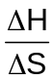.

2 The equilibrium yield of NH₃ can be improved by using powdered iron.

3 The equilibrium constant increases with increasing pressure.

[Turn over

A | B | C | D
1, 2 and 3  are  correct | 1 and 2  only are  correct | 2 and 3  only are  correct | 1 only  is  correct

34 Hydrazoic acid, HN₃, is a weak monobasic acid (pK_{a} = 4.72).

An aqueous sample contains 0.100 mol dm^{–3} of the acid at 298 K. Which of the following statements are correct?

[Data: K_{w} = 1.0 x 10^{–14} mol² dm^{–6} at 298 K]

1 The pH of the sample is 2.86.

2 The concentration of N₃– in the sample is 1.38 x 10^{–3} mol dm^{–3}.

3 The concentration of OH– in the sample is 7.24 x 10^{–12} mol dm^{–3}.

35 Use of the Data Booklet is relevant to this question.

X, Y and Z are Period 4 elements but are not necessarily arranged in order of increasing atomic number. Some of their properties are tabulated below.

Element | Density  / g cm⁻³ | Melting point  / ºC | Ion in which the element exists in its highest oxidation state | Formula and colour of a chloride formed by the element
X | – | –7 | XO₄– | XCl (red)
Y | 1.5 | 850 | [Y(edta)]^{2–} | YCl₂ (white)
Z | 7.2 | 1890 | ZO₄^{2–} | ZCl₃ (reddish-violet)

Which of the following statements are correct?

1 X has a smaller atomic radius than Y.

2 Y is not a transition element.

3 Z has six unpaired electrons in its ground state electronic configuration.

[Turn over

A | B | C | D
1, 2 and 3  are  correct | 1 and 2  only are  correct | 2 and 3  only are  correct | 1 only  is  correct

36 Use of the Data Booklet is relevant to this question.

The number of moles of chlorine that react with 1 mole of A is twice the number of moles of chlorine that react with 1 mole of B.

Which of these pairs could be A and B?

A B

1 Si(s) Mg(s)
2 cold Ba(OH)₂(aq) hot NaOH(aq)
3 FeBr₂(aq) KI(aq)

37 In the 1970s, chlorofluorocarbon (CFCs) was found to have destructive effects on the ozone layer in the atmosphere. It undergoes free radical reaction with ozone to form oxygen.

Which of the following reactions form part of the propagation step?

1 CFCl₃ ⎯⎯⎯→ •CFCl₂ + Cl•

2 Cl● + O₃ ⎯⎯⎯→ ClO● + O₂

3 ClO● + O₃ ⎯⎯⎯→ Cl● + 2O₂

38 Benzene is a cyclic aromatic hydrocarbon with 6 π electrons.

For a cyclic hydrocarbon to be aromatic, the molecule must

  - be planar
  - contain overlapping p orbitals on adjacent carbon atoms
  - contain (4n + 2) π electrons (n = 0, 1, 2, 3, and so forth)

Which of the following hydrocarbons
are aromatic?
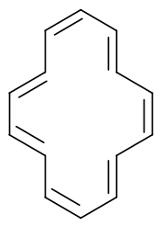

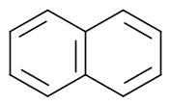
1 2 3

[Turn over

A | B | C | D
1, 2 and 3  are  correct | 1 and 2  only are  correct | 2 and 3  only are  correct | 1 only  is  correct

39 When a halogen-containing compound is hydrolysed with aqueous NaOH, the corresponding sodium halide, NaX, is produced.

A student investigated the number of moles of NaX produced by hydrolysing two halogen-containing compounds, P and Q, separately. The experimental results obtained are shown graphically below.

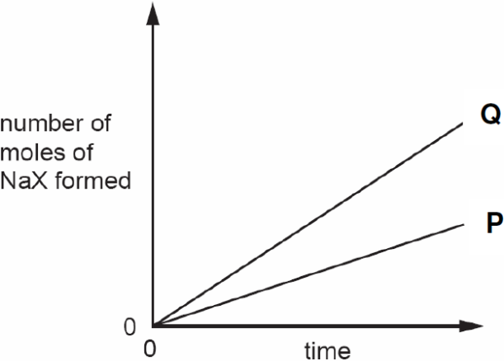

Which compounds could be P and Q?

P Q

1 CH₃CH₂Cl CH₃CH₂Br

2 CH₃CH₂Br BrCH₂CH₂Br

3 C₆H₅CH₂Cl CH₂=CHBr

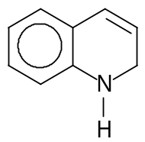
40 Compound Y has the following structure:

Which of the following react completely with 1 mol of Y?

1 1 mol of CH₃CH₂COCl

2 2 mol of HBr

3 3 mol of Br₂(aq)

⎯⎯⎯⎯ End of Paper ⎯⎯⎯⎯

